***Mammoth Fling***

By *team* ***Bandits***

***Team Members:***

1. ***Muhammad Ahsan DIscord: (ahsan_961#5486)***
2. ***Muhammad Affan Discord: (kakanics#4652)***
3. ***Danial Saleem Discord: (blackboy#2034)***

**Overview/Theme** **2**

Idea Summary 2

Goal 2

Why It Will Succeed 2

**Mock Ups** **3**

**References** **3**

**Art Style** **3**

**Look & Feel / Camera** **4**

**Mechanic** **4**

Controls 4

Core Loop (Feel Free to Replace Diagram Below) 5

**Progression** **5**

# Overview/Theme

## Idea Summary

**Describe the idea, including some basic background and short description of the game.**

**Background:** In "Elephant Swing," players are introduced to an adorable elephant who loves swinging through the jungle. The elephant is on a thrilling adventure, navigating a world filled with hooks, challenges, and collectibles. The game features a unique slingshot mechanism that allows players to throw the elephant from one hook to another.

**Description:** "Elephant Swing" is a hypercasual top-scrolling endless game where the player controls an elephant hanging from hooks. The objective is to throw the elephant from one hook to the next using a slingshot mechanism, ensuring the chosen hooks can support the elephant's weight. Hooks have different weight limits, and if the elephant's weight exceeds the hook's capacity, the hook will break, resulting in a fall. Along the way, players will encounter two types of collectibles: weight increasers and weight decreasers. The elephant’s weight will affect its appearance, making it fatter as its weight increases. Players must strategically decide which collectibles to gather to maintain an optimal weight for the upcoming hooks.

## Goal

**What's the ultimate aim of the player playing this game?**

The ultimate aim of the player is to navigate the elephant as far as possible through the endless jungle by successfully swinging from hook to hook. The player must maintain a balance in the elephant’s weight to ensure it can continue progressing without breaking the hooks. The goal is to achieve the highest score by covering the maximum distance while collecting beneficial items and avoiding those that could lead to an untimely fall.

**Why will it be fun, entertaining or satisfying?**

"Elephant Swing" will be fun, entertaining, and satisfying for several reasons:

* **Strategic Gameplay:** Players must think quickly and strategically, deciding which hooks to aim for and which collectibles to gather to manage the elephant's weight effectively.
* **Dynamic Mechanics:** The slingshot mechanism adds a layer of excitement and skill, requiring precise timing and aim.
* **Progressive Challenge:** As the game progresses, the challenge increases, with hooks having varying weight limits and collectibles appearing more frequently, keeping players engaged.
* **Visual Appeal:** The elephant’s changing appearance as it gains or loses weight adds a humorous and visual element that enhances the gaming experience.
* **Endless Replayability:** The endless nature of the game encourages players to keep playing to beat their high scores and discover new strategies for surviving longer.

# Mock Ups

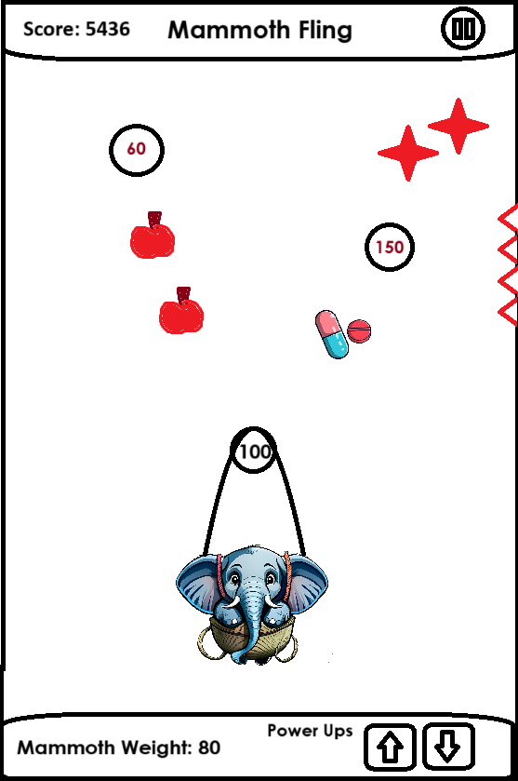

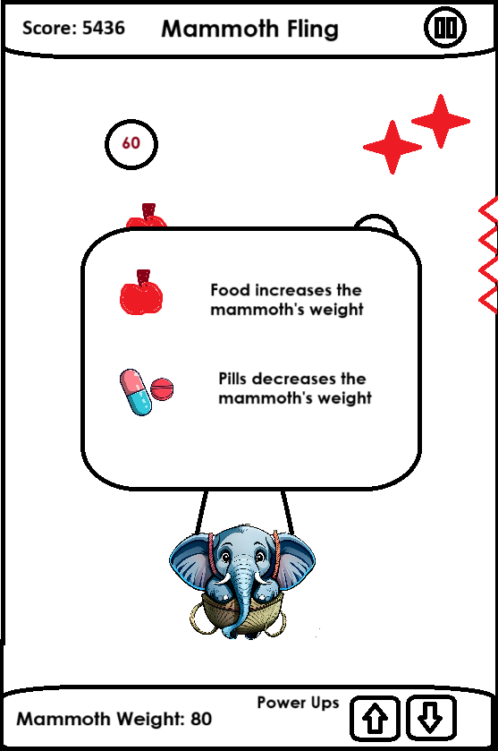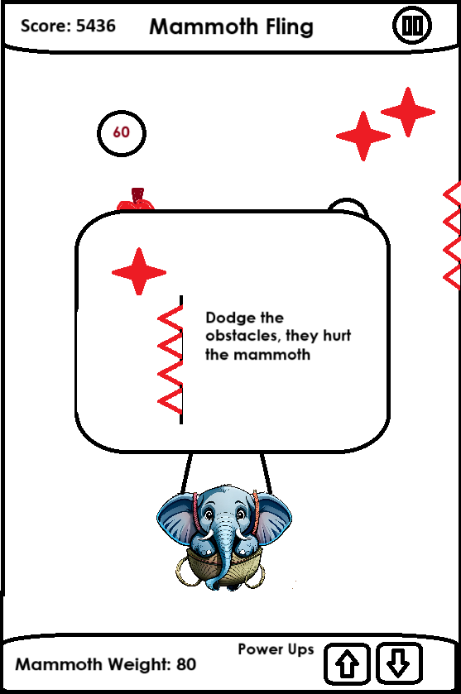

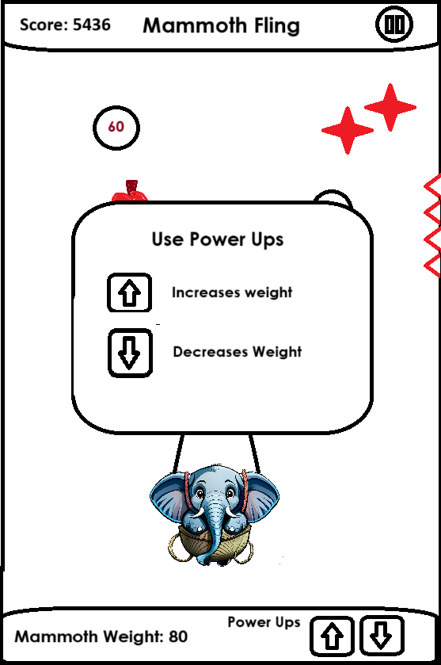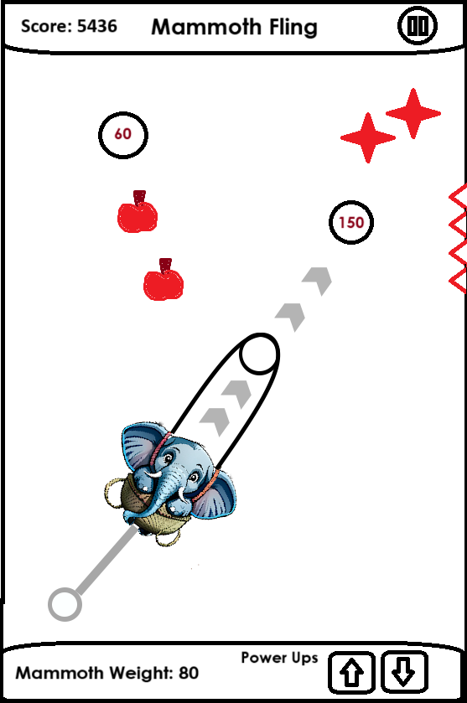

# Art Style

* 2D
* Cartoon
* Low Poly
* Isometric

# Look & Feel / Camera

* Face On

# Mechanic

## Controls

* Portrait
* Tap
* Swipe
* Hold
* Release
* Drag

## Core Loop (Feel Free to Replace the Diagram Below)



# Progression

* Level Based
* Score Based

____________________________________________________________________________